EHCCA

**East Hertfordshire Church**

**Choirs Association**

*Patron: The Bishop of St Albans,*

*the Rt. Revd. Alan Smith*

*President: Derek Harrison, MA, FRCO*

**ST MARY THE VIRGIN,**

**HATFIELD BROAD OAK**

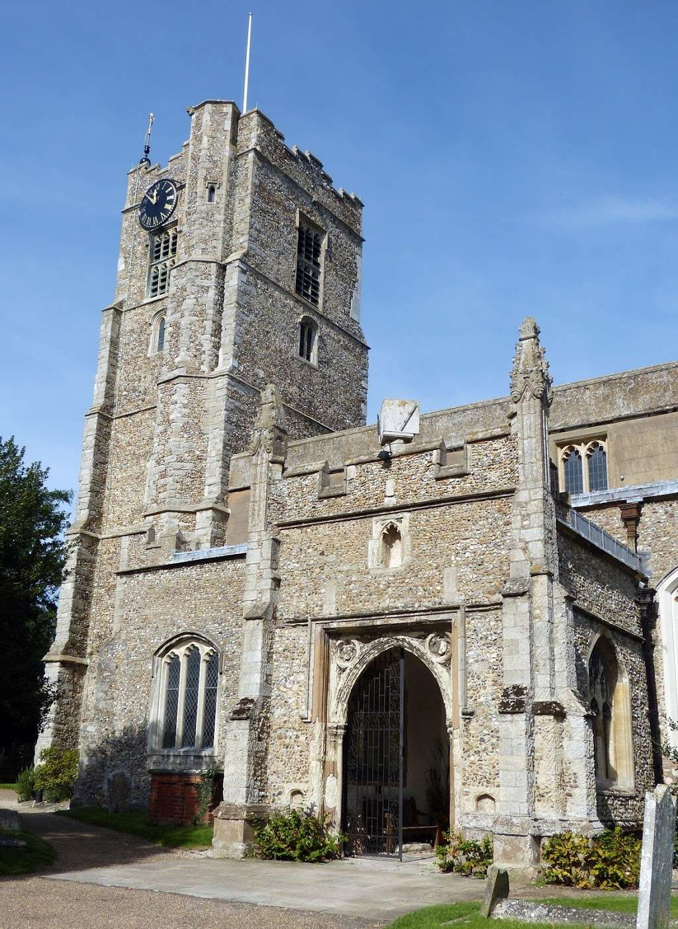

**SUNDAY**

**17th OCTOBER 2021,**

**6.30PM**



FESTIVAL EVENSONG

**Music includes:**

**Brewer in D**

**Farrant: Lord for Thy tender mercy**

**Wood: O Thou the Central Orb**

**Conductor: Derek Harrison**

**Organist: Oliver Bond**

*Retiring Collection in aid of EHCCA and the church*