EHCCA

East Hertfordshire Church
Choirs Association
Patron: The Bishop of St Albans,
the Rt. Revd. Alan Smith
President: Derek Harrison, MA, FRCO

GREAT ST MARY, SAWBRIDGWORTH
Church Street CM219AJ

SUNDAY 23rd June 2024, 5pm

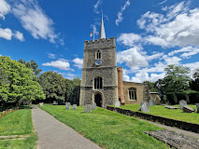
SUMMER FESTIVAL

EVENSONG

Led by

EHCCA Singers

CONDUCTOR
Edward Dodge
ORGANIST

Stephen Penton

Retiring Collection in aid of EHCCA and the church

